





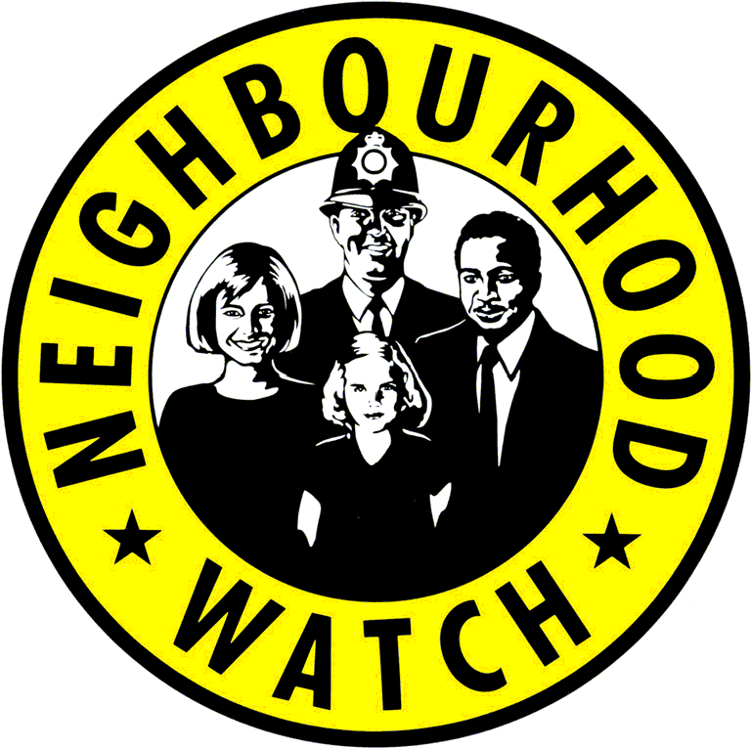



**Lewes Town and Rural**

**Neighbourhood Watch Association**

**Newsletter – July 2017**

**GARDEN SECURITY**

You may like to consider checking and improving your garden security this summer. Remember your garden is an access point into your home. Lockable gates and secure fencing are important. Thorny plants around the perimeter and trellis on top of fences make it harder for an intruder to access your garden.

Keep your ladder and garden tools locked away as they can be used by burglars to access your home. Keep tools indoors if you do not have a lockable garden shed.

Garden Security is not primarily aimed at preventing burglars stealing tools and equipment from your garden. Its main objective is to keep intruders out of your garden to prevent them getting into your home to steal your possessions.

For more information search the internet for Garden Security. The Royal Horticultural Society and SAGA websites give useful information. Garden security leaflets are available at Lewes Police station open weekdays 10 am to 2 pm.

**NEIGHBOURHOOD WATCH MEMBERSHIP**

We are trying to increase the number of people who are members of Neighbourhood Watch in the Lewes area. Currently 4,500 households belong to Neighbourhood Watch in the Lewes area; this represents 26% of the total number of households. We would like your help in increasing the number of households that we cover.

We ask street coordinators to check the area they cover to see if any households are being missed out. There may be new-builds or people have moved away and have not notified their coordinator. You could consider increasing your coverage by embracing a neighbouring street that is not covered by neighbourhood watch.

Members may like to talk about Neighbourhood Watch with their friends and relations. Try to find out if they are covered and if not are they interested in joining Neighbourhood Watch.

**WHICH STREETS ARE ALREADY COVERED?**

You can check which streets are already covered by a Neighbourhood Watch Scheme on our website [www.lewesnwa.org.uk](http://www.lewesnwa.org.uk)

* Click on the ‘**our schemes’** button to display the scheme totals
* Click on **‘scheme map’** to display a map of the overall area that we cover.
* Enter a postcode and press **‘Go’** to display existing Neighbourhood Watch Schemes within ½ mile radius of that postcode.
* Click on any marker for more details about that scheme.

You may change the area covered on the map, or enter unique street or village names. Press **‘Go’** after any change to refresh the map.

**CONTACT US**

We would welcome your views on Neighbourhood Watch in the Lewes area.

Also please let us know of friends or relations who would like to join Neighbourhood Watch.

By email: [nwareport@lewesnwa.org.uk](mailto:nwareport@lewesnwa.org.uk)

Phone: 01273 473227

Website: [www.lewesnwa.org.uk](http://www.lewesnwa.org.uk)

click on **contacts**